

Data Visualization

Submitted By:

Naresh Kumar Pendyala

11013408

**Submitted By:**

**Naresh Kumar Pendyala**

**11013408**

Question 1, 7

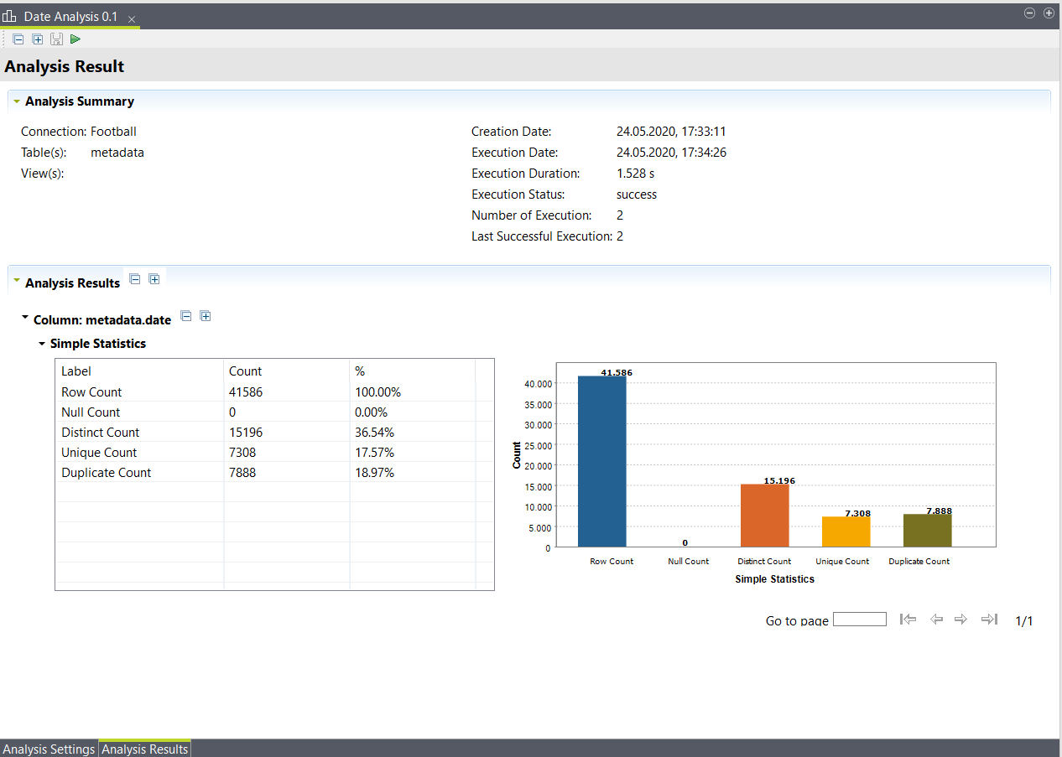

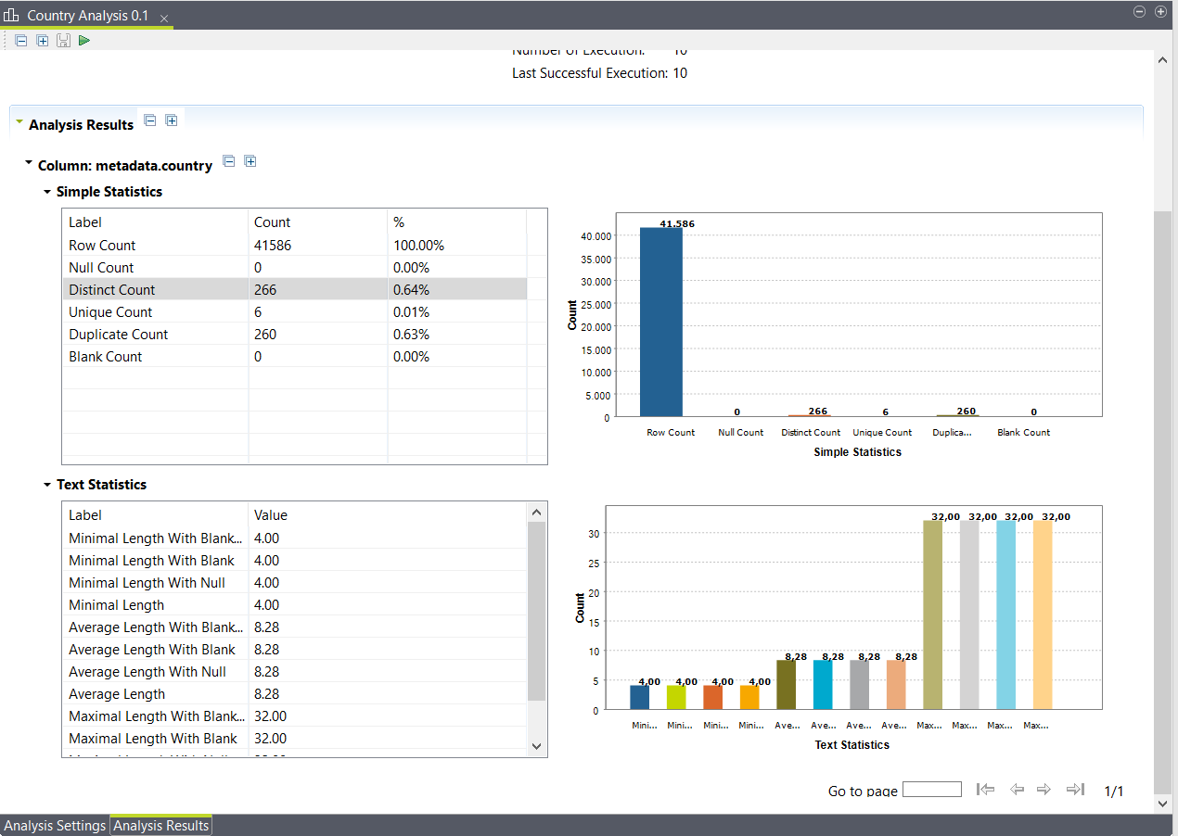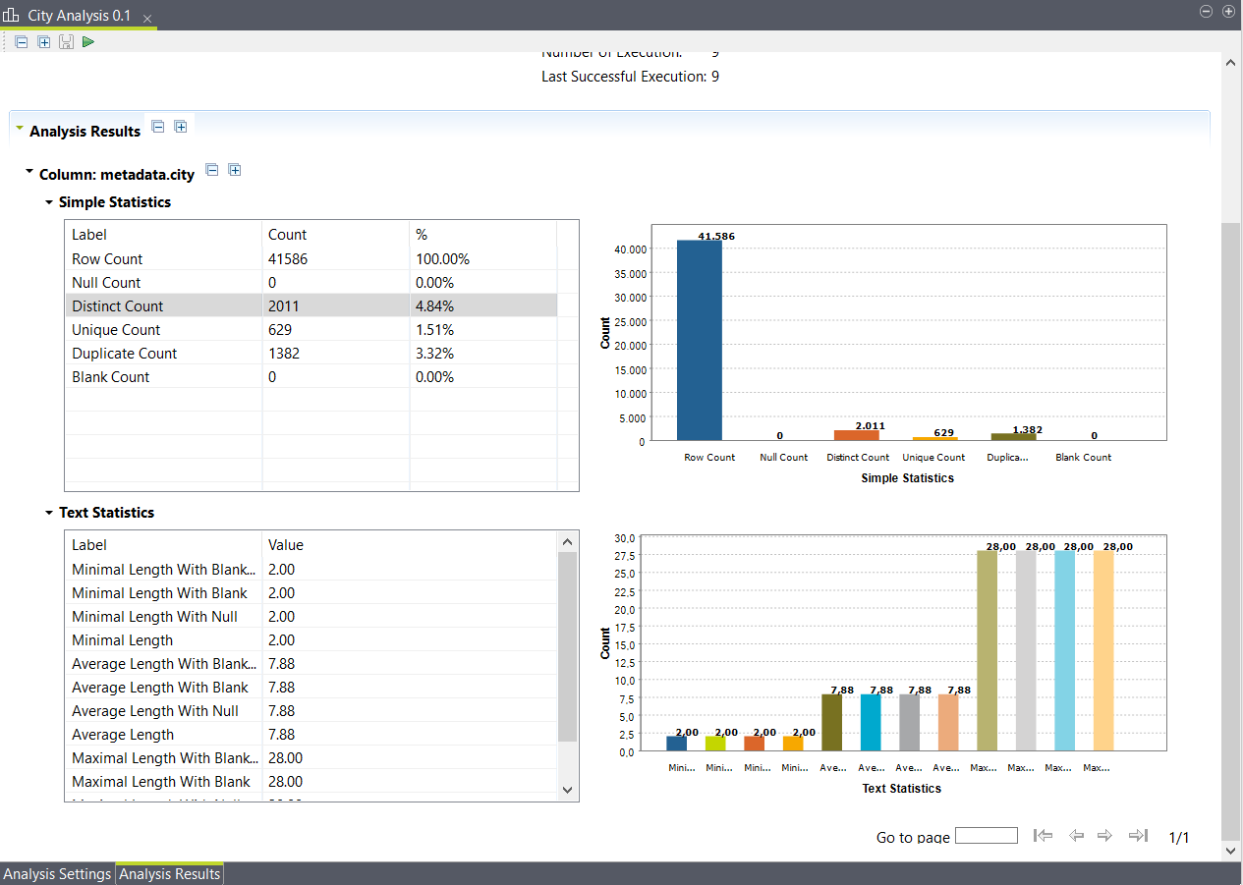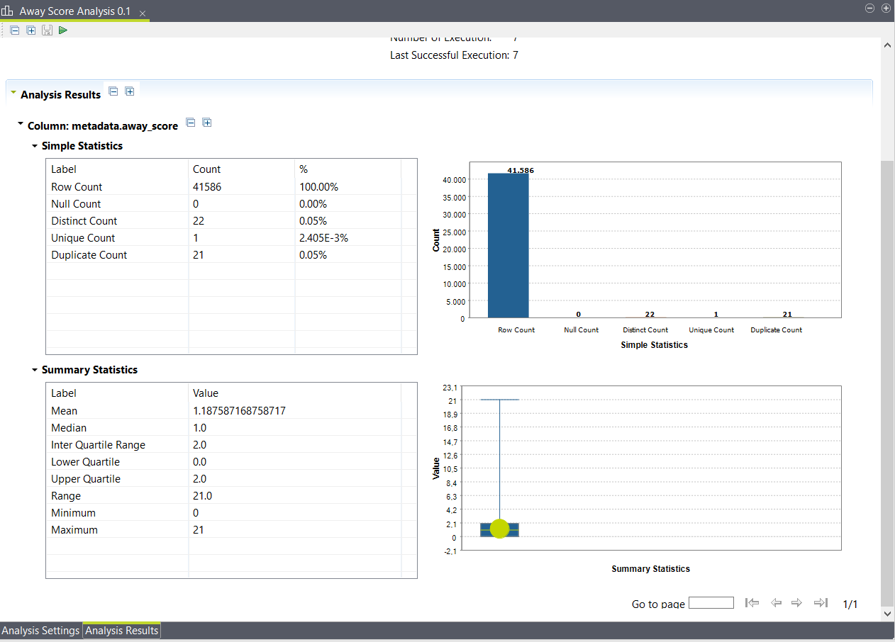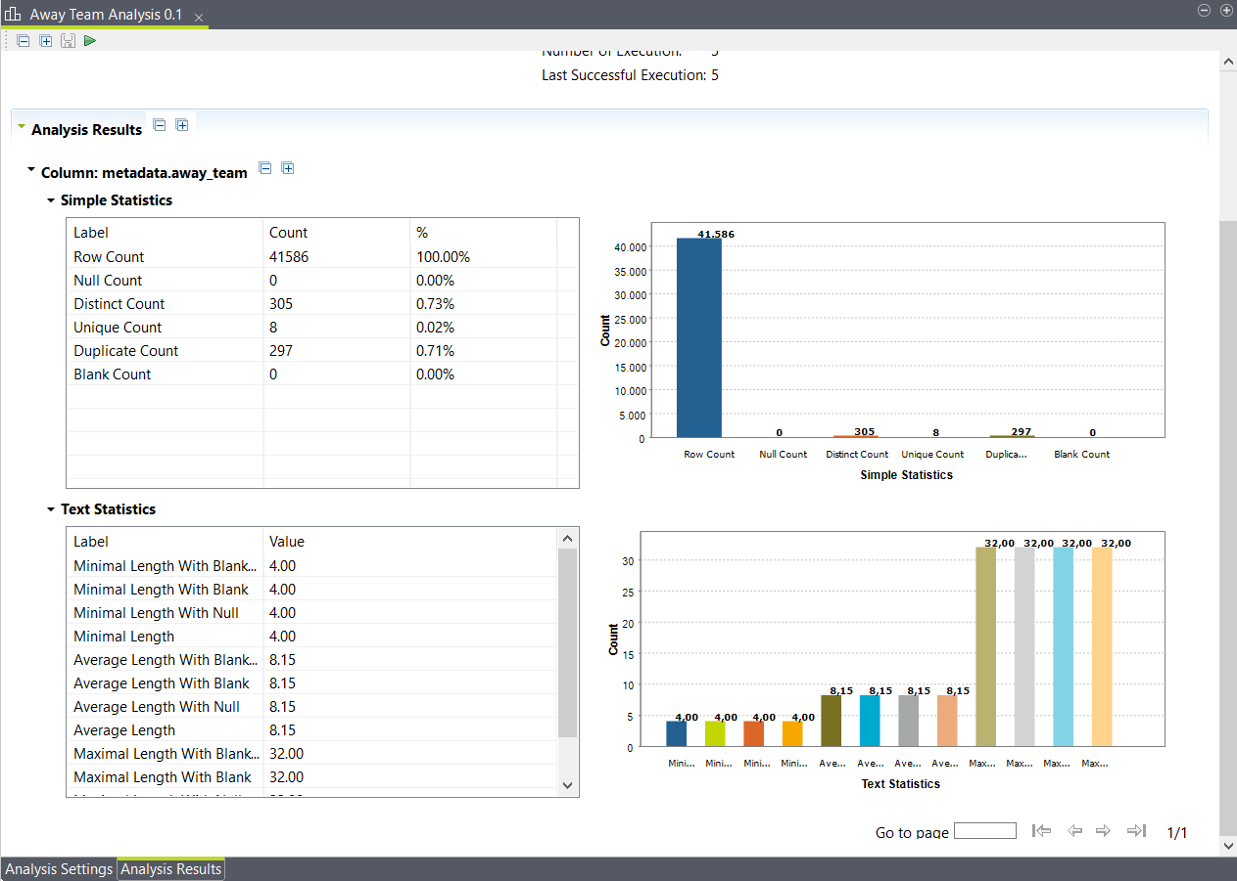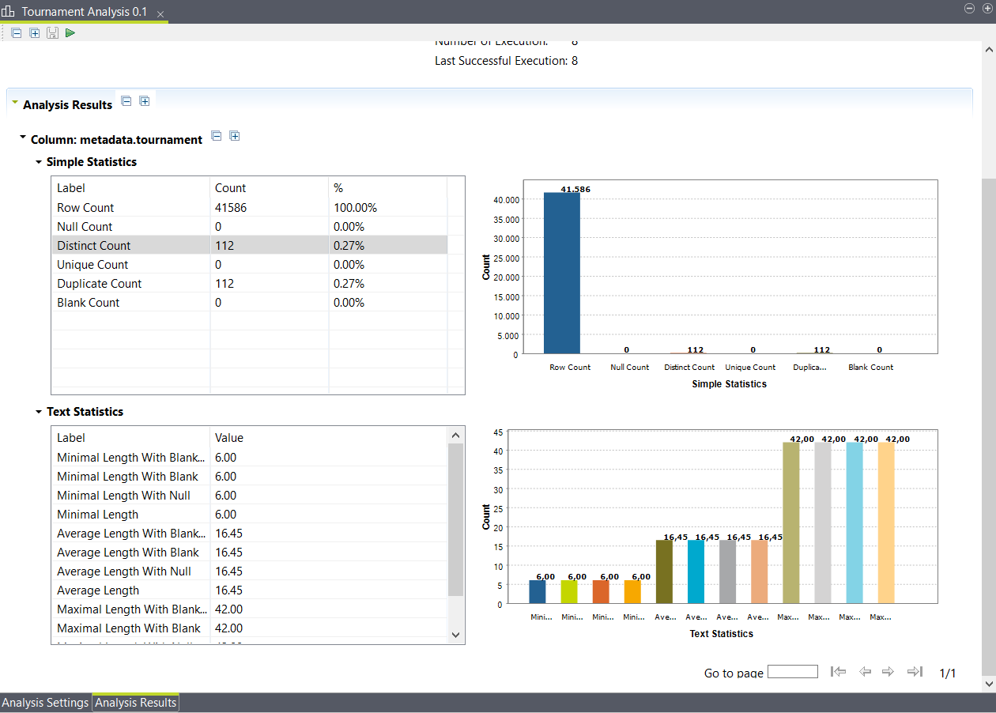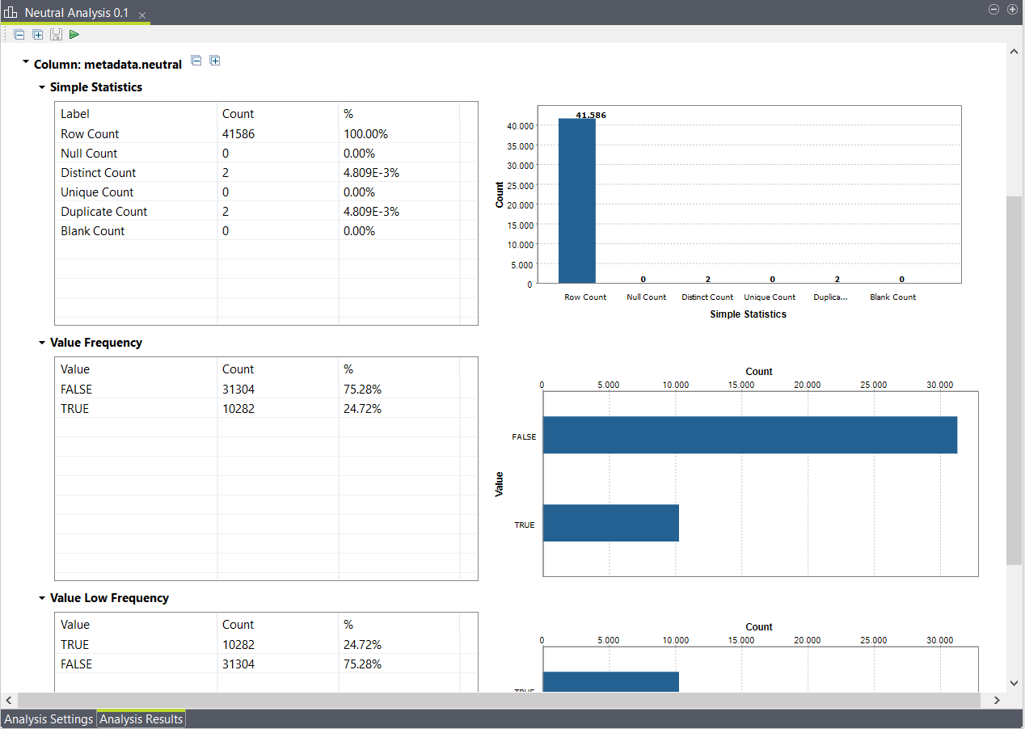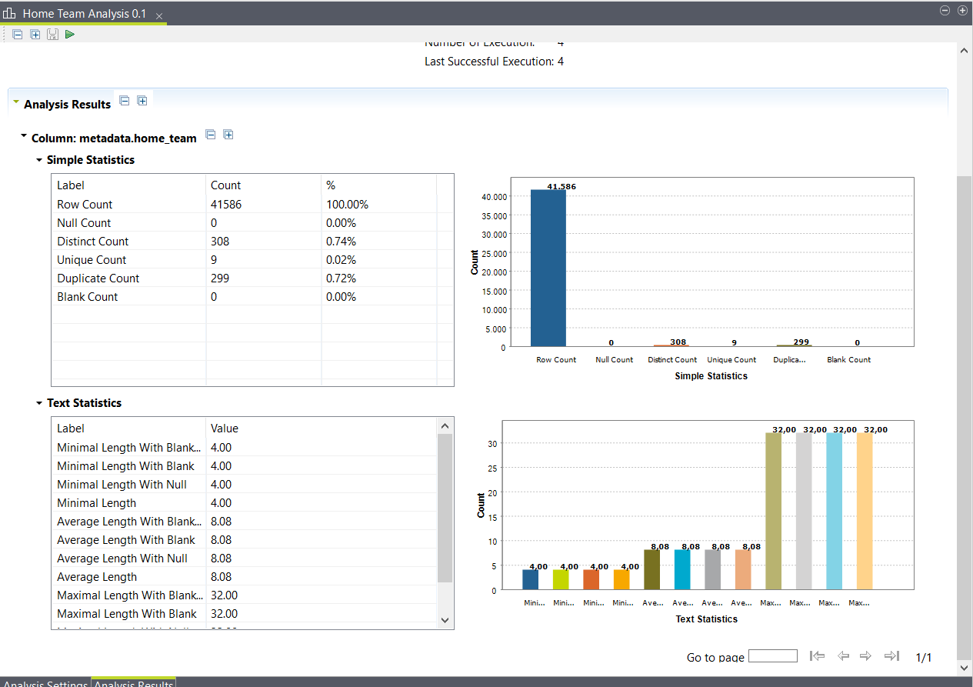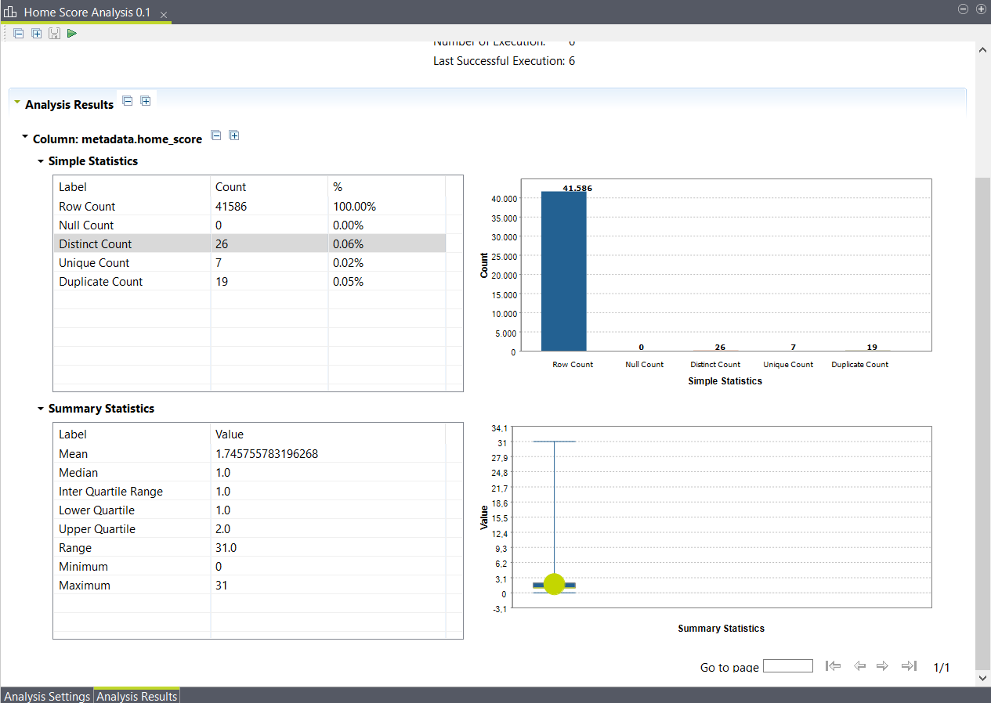

Question 2

# **Persona**

## Owner (Jim)



**Motivation:** Naresh is a Germany football manager with immense passion, and vision.

**Challenges**:

To win the 2022 world cup which will be conducted in Qatar.

**Needs/Wants**:

He wants the star, and young talented players.

The main XI should get the more game play, and opportunities in domestic leagues to persist their form.

Need the new, effective and counter tactics like 2014 semifinal where Germany trashed Brazil 7-1.

**Name:** Naresh

**Profession**: Germany Football Manager

**Fan Club:** Fc Bayern Munich

**Age**: 25

**Marital Status:** Single

**.**

**.**

Question 3

**What does your audience care about?**

* The audience main motive to claim the 2022 world cup title.
* The manager desiring to bring new and an effective tactics into the game to win the world cup 2022.

Question 4

**What are the benefits if your audience acts in the way that you want them to?**

* By manipulating the current tactics with 2014, 2006, and 2000 tactics then they can easily achieve what they want.
* If they follow our guidance, they there is a chance to win the 2022 world cup.

Question 5

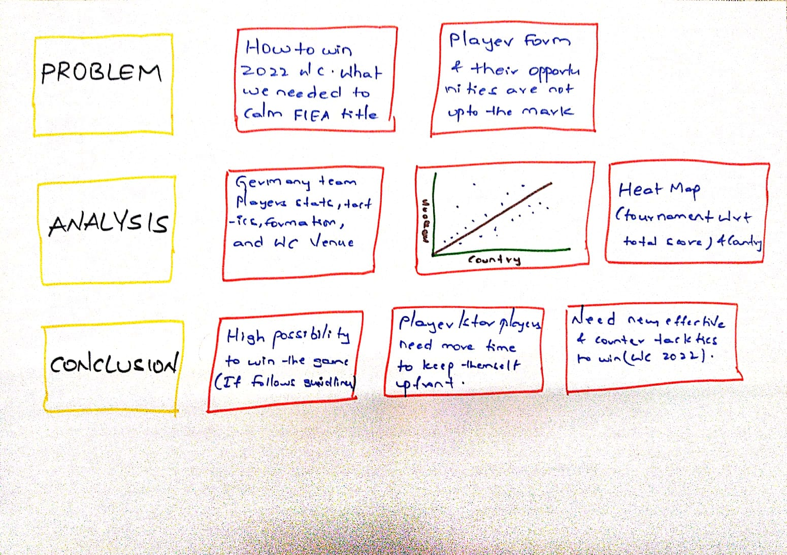

Question 6

**Data Set Types:**

1. Date
2. Text/String
3. Integer/Numeric
4. Boolean/Logical

**Number of attributes: 9**

1. Date (date)
2. Home Team (string)
3. Away Team (string)
4. Home Score (integer)
5. Away Score (integer)
6. Tournament (string)
7. City (string)
8. Country (string)
9. Neutral (Boolean)

**Number of records: 41587**

THE END